February 11, 2015

RE: Tagging Fundraising Policy

Our Annual Tagging weekend is our only Mandatory Fundraiser for the year for the regular season. And it helps keep our registration costs below the league average. We “book” our weekend 6 months in advance so it give parents enough time to schedule accordingly.

To be consistent with other sports teams in our town, effective starting the 2015 season there will be a $50 “Opt Out” fee for those parents who cannot / nor wish to have their children tag. We will do our best to honor everyone’s schedule requests and will be handled on a 1st come, 1st serve basis by our Fundraising Coordinator.

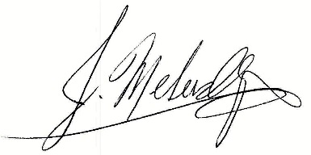
Jeremy Melusky
President, RGYF

